Q01.
<?xml version="1.0" encoding="UTF-8"?>
<students>
<student id="1" regNo="SEU/IS/20/ICT/084">
<name>Pasan Kalhara</name>
<department>ICT</department>
<gpa>3.8</gpa>
</student>
<student id="2" regNo="SEU/IS/20/BST/006">
<name>Tharushi Randhula</name>
<department>BST</department>
<gpa>4.0</gpa>
</student>
<student id="3" regNo="SEU/IS/20/ICT/026">
<name>Ishara Madhushanka</name>
<department>ICT</department>
<gpa>3.9</gpa>
</student>
<student id="4" regNo="SEU/IS/20/ICT/045">
<name>Sagara</name>
<department>ICT</department>
<gpa>2.0</gpa>
</student>
<student id="5" regNo="SEU/IS/20/BST/026">
<name>Amani</name>
<department>BST</department>
<gpa>3.0</gpa>
</student>
</students>

Q02.
<?xml version="1.0" encoding="UTF-8"?>
<library>
<book id="1" isbn="S001" category="ICT">
<title>C++</title>
<author>Saman Ekanayaka</author>
<price>1000.00</price>
</book>
<book id="2" isbn="S003" category="Enginering">
<title>Moter Macanic</title>
<author>Kavidhu Rathnayaka</author>
<price>12000.00</price>
</book>
<book id="3" isbn="S015" category="BST">
<title>BST</title>
<author>Sagara</author>
<price>1000.00</price>
</book>
<book id="4" isbn="S033" category="English">
<title>Romiyo Juliat</title>
<author>Rathnayaka</author>
<price>3000.00</price>
</book>
<book id="5" isbn="S063" category="Net Working">
<title>Net Working</title>
<author>Kavidhu Rathnayaka</author>
<price>1000.00</price>
</book>
</library>

Q03.
<?xml version="1.0" encoding="UTF-8"?>
<timeTable>
<Period id="1" day="Mon Day">
<subject>OOD</subject>
<time>8.00</time>
<lecturerName>Kalhara</lecturerName>
</Period>
<Period id="2" day="Tue Day">
<subject>NetWorke</subject>
<time>10.35</time>
<lecturerName>Damith</lecturerName>
</Period>
<Period id="3" day="Wens Day">
<subject>Progrming</subject>
<time>9.00</time>
<lecturerName>Kasun</lecturerName>
</Period>
<Period id="4" day="The Day">
<subject>Java Web Development</subject>
<time>2.00</time>
<lecturerName>Samitha</lecturerName>
</Period>
<Period id="5" day="Fri Day">
<subject>OOAD</subject>
<time>8.00</time>
<lecturerName>Ishara</lecturerName>
</Period>
<period id="6" day="sun Day">
<subject>C++ Progrmin</subject>
<time>3.00</time>
<lecturerName>Kalhara</lecturerName>
</period>
</timeTable>

Q04.
index.html
<!DOCTYPE html>
<html lang="en">
<head>
<meta charset="UTF-8">
<meta name="viewport" content="width=device-width, initial-scale=1.0">
<title>Q04</title>
</head>
<body>

<p>Book Title List</p>
<ul id="list"></ul>

<script>
const list = document.getElementById("list");
const parser = new DOMParser();

fetch('library.xml')
.then(response => response.text())
.then(xmlText => {
const xmlDoc = parser.parseFromString(xmlText, 'text/xml');
const library = xmlDoc.getElementsByTagName('book');

for (let i = 0; i < library.length; i++) {
const lib = library[i];
const title = lib.getElementsByTagName('title')[0]?.textContent.trim() || '';

const row = document.createElement('li');
row.innerHTML = `
<li>${title}</li>

`;
list.appendChild(row);

console.log(title);
}
})
.catch(err => {
console.error('Failed to load or parse library.xml:', err);
const row = document.createElement('tr');
row.innerHTML = `<li colspan="7">Failed to load library data.</li>`;
list.appendChild(row);
});
</script>

</body>
</html>

library.xml
<?xml version="1.0" encoding="UTF-8"?>
<library>
<book id="1" isbn="S001" category="ICT">
<title>C++</title>
<author>Saman Ekanayaka</author>
<price>1000.00</price>
</book>
<book id="2" isbn="S003" category="Enginering">
<title>Moter Macanic</title>
<author>Kavidhu Rathnayaka</author>
<price>12000.00</price>
</book>
<book id="3" isbn="S015" category="BST">
<title>BST</title>
<author>Sagara</author>
<price>1000.00</price>
</book>
<book id="4" isbn="S033" category="English">
<title>Romiyo Juliat</title>
<author>Rathnayaka</author>
<price>3000.00</price>
</book>
<book id="5" isbn="S063" category="Net Working">
<title>Net Working</title>
<author>Kavidhu Rathnayaka</author>
<price>1000.00</price>
</book>
</library>

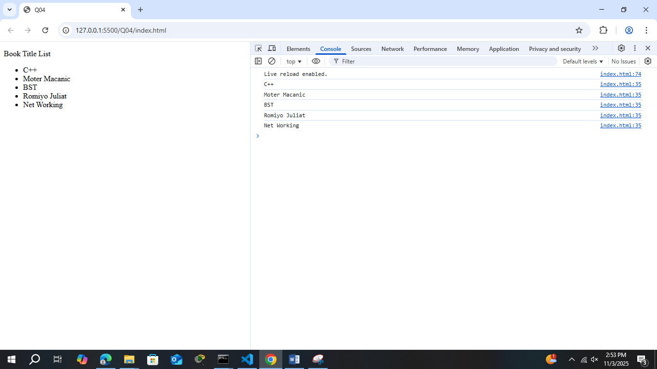
Q05.
index.html
<!DOCTYPE html>
<html lang="en">
<head>
<meta charset="UTF-8">
<meta name="viewport" content="width=device-width, initial-scale=1.0">
<title>Q05</title>
</head>
<body>

<p>Students List</p>
<table id="list" border="1">
<tr>
<th>Name</th>
<th>GPA</th>
</tr>
</table>

<script>
const list = document.getElementById("list");
const parser = new DOMParser();

fetch('students.xml')
.then(response => response.text())
.then(xmlText => {
const xmlDoc = parser.parseFromString(xmlText, 'text/xml');
const students = xmlDoc.getElementsByTagName('student');

for (let i = 0; i < students.length; i++) {
const std = students[i];

const gpa =std.getElementsByTagName('gpa')[0]?.textContent.trim() || '';

if(gpa >=3.5){
const name = std.getElementsByTagName('name')[0]?.textContent.trim() || '';
const row = document.createElement('tr');
row.innerHTML = `
<td>${name}</td>
<td>${gpa}</td>
`;
list.appendChild(row);

console.log(name);
}

}
})
.catch(err => {
console.error('Failed to load or parse students.xml:', err);
const row = document.createElement('tr');
row.innerHTML = `<td colspan="7">Failed to load students data.</td>`;
list.appendChild(row);
});
</script>

</body>
</html>

students.xml
<?xml version="1.0" encoding="UTF-8"?>
<students>
<student id="1" regNo="SEU/IS/20/ICT/084">
<name>Pasan Kalhara</name>
<department>ICT</department>
<gpa>3.8</gpa>
</student>
<student id="2" regNo="SEU/IS/20/BST/006">
<name>Tharushi Randhula</name>
<department>BST</department>
<gpa>4.0</gpa>
</student>
<student id="3" regNo="SEU/IS/20/ICT/026">
<name>Ishara Madhushanka</name>
<department>ICT</department>
<gpa>3.9</gpa>
</student>
<student id="4" regNo="SEU/IS/20/ICT/045">
<name>Sagara</name>
<department>ICT</department>
<gpa>2.0</gpa>
</student>
<student id="5" regNo="SEU/IS/20/BST/026">
<name>Amani</name>
<department>BST</department>
<gpa>3.0</gpa>
</student>
</students>

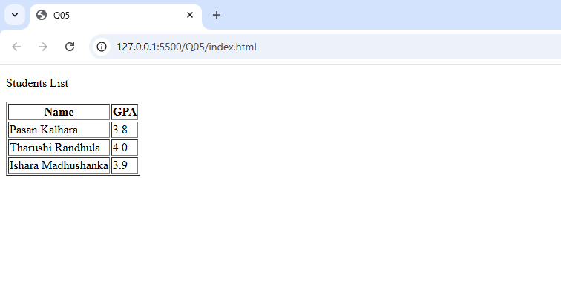
Q06.
index.html
<!DOCTYPE html>
<html lang="en">
<head>
<meta charset="UTF-8">
<meta name="viewport" content="width=device-width, initial-scale=1.0">
<title>Q06</title>
</head>
<body>
<p><strong>Old Book Table</strong></p>
<table id="oldlist" border="1">
<tr>
<th>Title</th>
<th>Author</th>
<th>Price</th>
</tr>
</table>

<p><strong>Updated Book Table</strong></p>
<table id="UpdateList" border="1">
<tr>
<th>Title</th>
<th>Author</th>
<th>Price</th>
</tr>
</table>

<script>
const oldlist = document.getElementById("oldlist");
const updatelist = document.getElementById("UpdateList");
const parser = new DOMParser();

fetch('library.xml')
.then(response => response.text())
.then(xmlText => {
const xmlDoc = parser.parseFromString(xmlText, 'text/xml');
const books = xmlDoc.getElementsByTagName('book');

for (let i = 0; i < books.length; i++) {
const title = books[i].getElementsByTagName('title')[0]?.textContent.trim() || '';
const author = books[i].getElementsByTagName('author')[0]?.textContent.trim() || '';
const price = books[i].getElementsByTagName('price')[0]?.textContent.trim() || '';

const row = document.createElement('tr');
row.innerHTML = `
<td>${title}</td>
<td>${author}</td>
<td>${price}</td>
`;
oldlist.appendChild(row);
}

if (books[1]) {
const priceNode = books[1].getElementsByTagName('price')[0];
if (priceNode) {
priceNode.textContent = '4000.00';
}
}

for (let i = 0; i < books.length; i++) {
const title = books[i].getElementsByTagName('title')[0]?.textContent.trim() || '';
const author = books[i].getElementsByTagName('author')[0]?.textContent.trim() || '';
const price = books[i].getElementsByTagName('price')[0]?.textContent.trim() || '';

const row = document.createElement('tr');
row.innerHTML = `
<td>${title}</td>
<td>${author}</td>
<td>${price}</td>
`;
updatelist.appendChild(row);
}

})
.catch(err => {
console.error('Failed to load or parse library.xml:', err);
const li = document.createElement('li');
li.textContent = 'Failed to load library data.';
oldlist.appendChild(li);
updatelist.appendChild(li.cloneNode(true));
});
</script>
</body>
</html>

library.xml
<?xml version="1.0" encoding="UTF-8"?>
<library>
<book id="1" isbn="S001" category="ICT">
<title>C++</title>
<author>Saman Ekanayaka</author>
<price>1000.00</price>
</book>
<book id="2" isbn="S003" category="Enginering">
<title>Moter Macanic</title>
<author>Kavidhu Rathnayaka</author>
<price>12000.00</price>
</book>
<book id="3" isbn="S015" category="BST">
<title>BST</title>
<author>Sagara</author>
<price>1000.00</price>
</book>
<book id="4" isbn="S033" category="English">
<title>Romiyo Juliat</title>
<author>Rathnayaka</author>
<price>3000.00</price>
</book>
<book id="5" isbn="S063" category="Net Working">
<title>Net Working</title>
<author>Kavidhu Rathnayaka</author>
<price>1000.00</price>
</book>
</library>

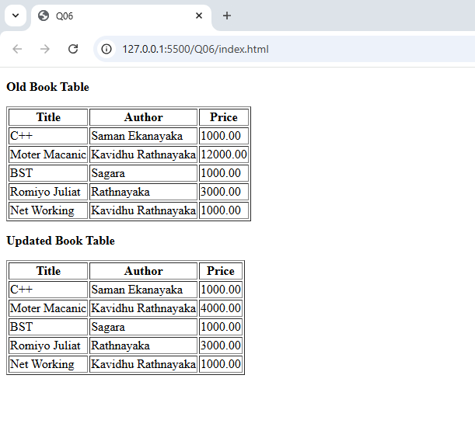
Q07.
index.html
<!DOCTYPE html>
<html lang="en">
<head>
<meta charset="UTF-8">
<meta name="viewport" content="width=device-width, initial-scale=1.0">
<title>Q07</title>
</head>
<body>
<p><strong>Old Book Table</strong></p>
<table id="oldlist" border="1">
<tr>
<th>Title</th>
<th>Author</th>
<th>Price</th>
</tr>
</table>

<p><strong>Updated Book Table</strong></p>
<table id="UpdateList" border="1">
<tr>
<th>Title</th>
<th>Author</th>
<th>Price</th>
</tr>
</table>

<script>
const oldlist = document.getElementById("oldlist");
const updatelist = document.getElementById("UpdateList");
const parser = new DOMParser();

fetch('library.xml')
.then(response => response.text())
.then(xmlText => {
const xmlDoc = parser.parseFromString(xmlText, 'text/xml');
const books = xmlDoc.getElementsByTagName('book');

for (let i = 0; i < books.length; i++) {
const title = books[i].getElementsByTagName('title')[0]?.textContent.trim() || '';
const author = books[i].getElementsByTagName('author')[0]?.textContent.trim() || '';
const price = books[i].getElementsByTagName('price')[0]?.textContent.trim() || '';

const row = document.createElement('tr');
row.innerHTML = `
<td>${title}</td>
<td>${author}</td>
<td>${price}</td>
`;
oldlist.appendChild(row);
}

if (books[1]) {
const priceNode = books[1].getElementsByTagName('price')[0];
if (priceNode) {
priceNode.textContent = '4000.00';
}
}
const newBook = xmlDoc.createElement('book');

const newTitle = xmlDoc.createElement('title');
newTitle.textContent = 'XML DOM Guide';
newBook.appendChild(newTitle);

const newAuthor = xmlDoc.createElement('author');
newAuthor.textContent = 'Rahul';
newBook.appendChild(newAuthor);

xmlDoc.documentElement.appendChild(newBook);
const updatedBooks = xmlDoc.getElementsByTagName('book');
for (let i = 0; i < updatedBooks.length; i++) {
const title = updatedBooks[i].getElementsByTagName('title')[0]?.textContent.trim() || '';
const author = updatedBooks[i].getElementsByTagName('author')[0]?.textContent.trim() || '';
const price = updatedBooks[i].getElementsByTagName('price')[0]?.textContent.trim() || '';

const row = document.createElement('tr');
row.innerHTML = `
<td>${title}</td>
<td>${author}</td>
<td>${price}</td>
`;
updatelist.appendChild(row);
}

})
.catch(err => {
console.error('Failed to load or parse library.xml:', err);
const row = document.createElement('tr');
row.innerHTML = `<td colspan="3">Failed to load library data.</td>`;
oldlist.appendChild(row.cloneNode(true));
updatelist.appendChild(row);
});
</script>
</body>
</html>

library.xml
<?xml version="1.0" encoding="UTF-8"?>
<library>
<book id="1" isbn="S001" category="ICT">
<title>C++</title>
<author>Saman Ekanayaka</author>
<price>1000.00</price>
</book>
<book id="2" isbn="S003" category="Enginering">
<title>Moter Macanic</title>
<author>Kavidhu Rathnayaka</author>
<price>12000.00</price>
</book>
<book id="3" isbn="S015" category="BST">
<title>BST</title>
<author>Sagara</author>
<price>1000.00</price>
</book>
<book id="4" isbn="S033" category="English">
<title>Romiyo Juliat</title>
<author>Rathnayaka</author>
<price>3000.00</price>
</book>
<book id="5" isbn="S063" category="Net Working">
<title>Net Working</title>
<author>Kavidhu Rathnayaka</author>
<price>1000.00</price>
</book>
</library>

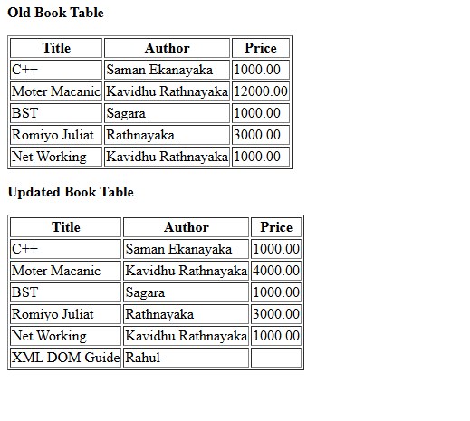

Q07.
index.html
<!DOCTYPE html>
<html lang="en">
<head>
<meta charset="UTF-8">
<meta name="viewport" content="width=device-width, initial-scale=1.0">
<title>Q08</title>
</head>
<body>
<p><strong>Old Book Table</strong></p>
<table id="oldlist" border="1">
<tr>
<th>Title</th>
<th>Author</th>
<th>Price</th>
</tr>
</table>

<p><strong>Updated Book Table</strong></p>
<table id="UpdateList" border="1">
<tr>
<th>Title</th>
<th>Author</th>
<th>Price</th>
</tr>
</table>

<script>
const oldlist = document.getElementById("oldlist");
const updatelist = document.getElementById("UpdateList");
const parser = new DOMParser();

fetch('library.xml')
.then(response => response.text())
.then(xmlText => {
const xmlDoc = parser.parseFromString(xmlText, 'text/xml');
const books = xmlDoc.getElementsByTagName('book');

for (let i = 0; i < books.length; i++) {
const title = books[i].getElementsByTagName('title')[0]?.textContent.trim() || '';
const author = books[i].getElementsByTagName('author')[0]?.textContent.trim() || '';
const price = books[i].getElementsByTagName('price')[0]?.textContent.trim() || '';
const row = document.createElement('tr');
row.innerHTML = `
<td>${title}</td>
<td>${author}</td>
<td>${price}</td>
`;
oldlist.appendChild(row);
}

if (books[1]) {
const priceNode = books[1].getElementsByTagName('price')[0];
if (priceNode) {
priceNode.textContent = '4000.00';
}
}

if (books[0]) {
const priceNode = books[0].getElementsByTagName('price')[0];
if (priceNode) {
books[0].removeChild(priceNode);
}
}

const newBook = xmlDoc.createElement('book');
const newTitle = xmlDoc.createElement('title');
newTitle.textContent = 'XML DOM Guide';
newBook.appendChild(newTitle);
const newAuthor = xmlDoc.createElement('author');
newAuthor.textContent = 'Rahul';
newBook.appendChild(newAuthor);
xmlDoc.documentElement.appendChild(newBook);

const updatedBooks = xmlDoc.getElementsByTagName('book');
for (let i = 0; i < updatedBooks.length; i++) {
const title = updatedBooks[i].getElementsByTagName('title')[0]?.textContent.trim() || '';
const author = updatedBooks[i].getElementsByTagName('author')[0]?.textContent.trim() || '';
const price = updatedBooks[i].getElementsByTagName('price')[0]?.textContent.trim() || '';
const row = document.createElement('tr');
row.innerHTML = `
<td>${title}</td>
<td>${author}</td>
<td>${price}</td>
`;
updatelist.appendChild(row);
}
})
.catch(err => {
console.error('Failed to load or parse library.xml:', err);
const row = document.createElement('tr');
row.innerHTML = `<td colspan="3">Failed to load library data.</td>`;
oldlist.appendChild(row.cloneNode(true));
updatelist.appendChild(row);
});
</script>
</body>
</html>

library.xml
<?xml version="1.0" encoding="UTF-8"?>
<library>
<book id="1" isbn="S001" category="ICT">
<title>C++</title>
<author>Saman Ekanayaka</author>
<price>1000.00</price>
</book>
<book id="2" isbn="S003" category="Enginering">
<title>Moter Macanic</title>
<author>Kavidhu Rathnayaka</author>
<price>12000.00</price>
</book>
<book id="3" isbn="S015" category="BST">
<title>BST</title>
<author>Sagara</author>
<price>1000.00</price>
</book>
<book id="4" isbn="S033" category="English">
<title>Romiyo Juliat</title>
<author>Rathnayaka</author>
<price>3000.00</price>
</book>
<book id="5" isbn="S063" category="Net Working">
<title>Net Working</title>
<author>Kavidhu Rathnayaka</author>
<price>1000.00</price>
</book>
</library>

